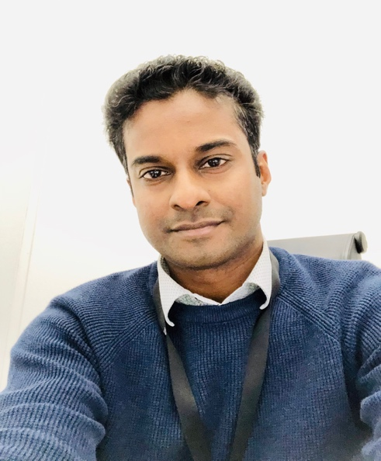  Nyjil Joshi  Solution Architect, Business Consultant, Transition lead § Data Architect.  B com, MCA, MBA, PMP, ITIL  Salesforce certifications  1.Sharing & visibility designer  2.Einstein discovery Plus  3.Sales cloud consultant  4.Service cloud consultant  5.Marketing cloud email specialist 6.Platform app builder consultant  7.Platform developer I  8.Administrator  Accomplishments  - Established salesforce practice for Dell Service, India from the ground up.  - Founded a consulting company in Salesforce and handled the role of a CEO for 2 years.  - Started the Marketing Cloud practice for PwC, India.  - An avid blogger with a strong LinkedIn presence. https://nyjiljoshy.wordpress.com/blog/  Working Languages  English  Salesforce Products  Sales Cloud,  Marketing Cloud,  Custom Cloud,  Service Cloud,  Einstein Discovery Plus,  Health Cloud  Lightning Messaging  Chat and SMS  FB integration.  Skills  Pre-sales  Proposals  Configurations Process design  Solution Design  Strategy & Concept Development Reporting & Analytics  Einstein Analytics  Project Management  Program Management  Agile Scrum Master  Estimations  Resource management  Proven Practice Leader  Data Analysis  Contact details:  Ph: +46 730 35 1987  Email: Nyjiljoshi@yahoo.com |  | Nyjil has 20 years of experience in working in various roles among sales, marketing, delivery and product management functions. In these positions he has been developing products & processes, leading projects and helping sales to close the deals.  After starting with Salesforce practice in 2012, he has already taken part in multiple Salesforce projects working in the capacity of an Analyst, Configurator, Delivery manager, practice Director, Scrum master for salesforce projects & recently worked as a Solution Architect. He has handled requirements gathering, proposals and estimations for salesforce projects. Nyjil was part of the team that established a quality framework for salesforce practice. He was also a co-founder in a software consultancy start-up of ten people where he played the role of CEO.  Achievements  - PwC : Spot Award & Project awards (2018)  - Dell Services : Silver Award, Delivery Management (2013)  - Symantec : Applause Awards (2011, 2010)  - Symantec : Learning Excellence Award (2011)  - Symantec : Spot Light Award (2010, 2009)  - Symantec : Collaboration Award (2009)  - Symantec : Valuable Player Award (2008)  - Symantec : CEO Top off Award (2007)  - IBM : Certificate of Excellence (2005)  - Apar (Ness) : Certificate of Appreciation  Salesforce Project Experience  Period: Nov/2019 to till date Role : Solution Architect Client: Miljonlotteriet, Gothenburg Company : Fluido  As a Solution Architect,  - Designed the models for Customer Lifetime Value and customer churn analysis.  - Designed models to understand customer attributions using data from Google analytics.  - Configured models to run Stories and extracted key insights from them to be shared with C-level team.  - Configured complex dashboards and with components that were enhanced using complex SAQL.  - Spearheaded design discussions with 3rd party systems to extract and load data into Sales Cloud Big objects.  - Designed data modelling and integrations between Marketing cloud and Web applications using REST API calls.  - Integrated Google Analytics with Einstein Analytics using connectors to tie CRM data with customer behavior data for a 360 analysis.  - Created churn prediction dashboard components to enable quick decisions making for the executive team during times of pandemic.  - Well versed with working with Datasets, Recipes, Dataflows, GA connector and SAQL.  - Created sales collaterals and technical blogs to assist the client to create awareness of its efforts in understanding the customer and thus preventing churn.  Period: 04/2019 to 11/2019 Role: Salesforce Transition Lead, Solution Architect. Client: Volvo Cars, Gothenburg. Company : Fluido.  As a versatalist he played several roles from proposal drafting, transition planning and taking over the role of a solution architect handling solution design in Sales Cloud, Custom Cloud, Marketing Cloud, Integrations, Communities and finding innovative ways to improve platform performance in outbound communication area. Worked with lead management, test drive bookings and Opportunity sales process design in multiple markets like EMEA and APAC. He was one of the key decision maker in design authority review meetings and played key role in bringing in innovative solutions to ensure a better customer experience and also ensured platform was used in a way that ensured better adoption by sales consultants (Partners) and NSC agents of Volvo Cars.  02/2019 to 03/2019: Salesforce Sales cloud reporting Client: Itivity, Stockholm Company : Fluido.  Developed management reports for pipeline analysis, sales velocity calculation, 12 month rolling pipeline analysis based on trends, created snapshot reports for storing pipeline data based on a given date for a client in financial domain.  Period: 04/2017 to 12/2018  Role: Technical Manager  Company: PWC, Bangalore.  Salesforce Sales Cloud Implementation – Healthcare Offshore team lead and project manager for a project that involved sales cloud enhancements and large volumes of legacy data migrations using Informatica Powercenter as a migration tool. Handled quality and data migration team apart from handling Salesforce team management and data analysis and data mappings.  Salesforce Sales Cloud Implementation – Real Estate Offshore team lead and project manager for a project that involved sales cloud implementation, integration with billing systems and legacy data migration to salesforce. Handled documentation, quality, agile framework implementation, scrum handling and people management. Implemented CICD processes using eclipse, github and jenkins. Code quality was governed by implementing static code scanner tool codescan.  Salesforce Marketing Cloud prototype – Insurance / Automobile. Involved as a Solution lead to create a working prototype of an email campaign journey. Devised solution approach to data load, journey automation based on segmentation of customers using inputs from data science team.  Period: 07/2012 to 03/2017  Role: Director/Project Manager, startup  Project: Salesforce Sales Cloud Implementation for J&J  Company: Cloudunbound Technologies, Bangalore.  Project manager and scrum master for Sales cloud customization that involved creating an application for assisting sales personnel in knowing medical consumables usage at various provider facilities. It was used in forecasting and targeted sales activities.  As a Director,  Established a startup company with 7 resources and 3 verticals like training, solutions and services. Designed and architected a financial solution prototype for financial market using force.com platform. Brought resources and force.com applications under a company frame work and evangelized SFDC technology in engineering college by giving training to 45 students. Handled project delivery management for overseas client’s in Australia including campaigns and Lead generation activities for CloudUnbound.  Established connects with C-level leaders and departmental heads for generating new Client engagements. Forged partnerships with a similar consulting company for joint go to market in India for SFDC practice. Developed technology related collaterals like websites content, blogs, whitepapers etc for the organizations. Implementing strategies, mentoring and management of resources. Working on proposals, BRD’s and spearheading client discovery calls sessions.  Period: 10/2012 to 03/2015  Role: Salesforce Practice Lead  Company: Dell Services  Started the Salesforce.com Consulting practice for Dell Services from the ground up in India, Bangalore and Noida. Handled teams reporting from Cyberjaya Malaysia, Noida and Bangalore. Managed massive hiring of Salesforce.com resources in various roles. Managed multiple projects as India Delivery manager, multiple project managers were direct reports and trained fresher’s and brought them up to speed in Force.com technology, lead the initiative. Also took part in RFP’s, proposal’s, estimations and even architected solutions.  Period: 02/2006 to 10/2012  Role : Salesforce Business Analyst and configurator Company: HP(Team acquisition from Symantec) .  Played a business analyst role for Sales cloud project with content management system enhancements. Handled requirement gathering, configuration and work coordination in salesforce project. Handled oracle fusion middleware configuration tasks with Siebel, Oracle CRM Ondemand and salesforce.com.  Period: 11/1999 to 02/2006  Company : Oak Solutions, Ness Global, IBM  Role: Amdocs ClarifyCRM consultant (US, Malaysia & India)  Functioned as a CRM consultant handling configuration, coding, data migration and data quality. Handled integration tasks from ClarifyCRM to other legacy systems, version upgrades and data base tuning for loading data. Worked in service, sales and quality modules of Amdocs ClarifyCRM suite. Worked in Telecom domain handling client projects for Reliance Infocomm, Sprint PCS and Celcom Malaysia.  Other areas of interest  - Completed training in IoT (non salesforce)  - Attended workshops in Mulesoft

